**TrafficTelligence:**

**Advanced**

**Traffic**

**Volume**

**Estimation**

**with Machine Learning**

A

Project

Report

submitted

in

partial

fulfillment

of

the

requirements

of

**ARTIFICIAL**

**INTELLIGENCE**

**AND**

**MACHINE**

**LEARNING**

Internship

with

**SMARTBRIDGE**

in

collaboration

**APSCHE**

by

**GREESHMA**

**N**

**Team**

**ID:**

**LTVIP2025TMID45739**

**greeshmasweety2005@gmail.com**

**SRI**

**VENKATESWARA**

**COLLEGE**

**OF**

**ENGINEERING,**

**TIRUPATI**

|  |  |  |  |
| --- | --- | --- | --- |
| **Project Table of Contents** | | | |
|  | **S. No** | **Contents** | **Page No.** |
|  | **1** | **Introduction**  **1.1 Project Overview**  **1.2 Purpose** | 01 |
| **2** | **Ideation Phase**  **2.1 Problem Statement**  **2.2 Empathy Map Canvas**  **2.3 Brainstorming** | 02-03 |
| **3** | **Requirement Analysis**  **3.1 Customer Journey Map**  **3.2 Solution Requirement**  **3.3 Data Flow Diagram**  **3.4 Technology Stack** | 04-05 |
| **4** | **Project Design**  **4.1 Problem Solution Fit**  **4.2 Proposed Solution**  **4.3 Solution Architecture** | 06-07 |
| **5** | **Project Planning & Scheduling**  **5.1 Project Planning** | 08 |
| **6** | **Functional and Performance Testing**  **6.1 Performance Testing** | 09 |
| **7** | **Results**  **7.1 Output Screenshots** | 10 - 13 |
| **8** | **Advantages & Disadvantages** | 14 |
| **9** | **Conclusion** | 15 |
| **10** | **Future Scope** | 16 |
| **11** | **Appendix** | 17 |
|  | **Source Code (if any)** |  |
|  | **Dataset Link** |  |
|  | **GitHub & Project Demo Link** |  |
|  | | |

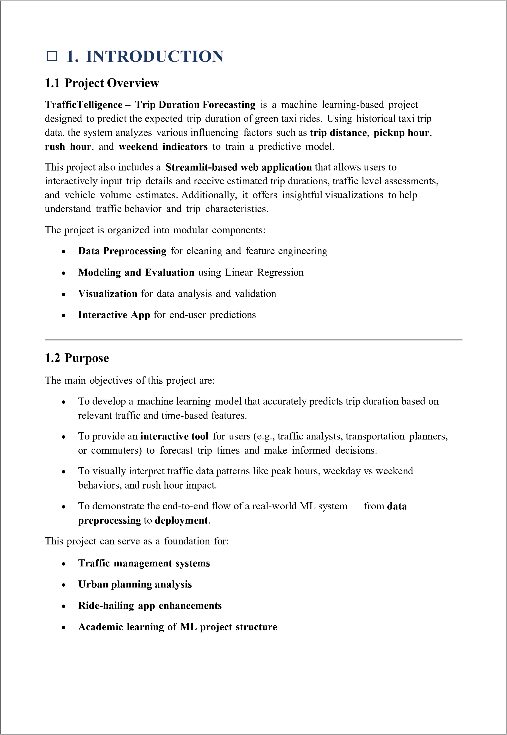

# 2. IDEATION PHASE

## 2.1 Problem Statement

Urban traffic congestion is a growing challenge in modern cities. Traditional systems lack the capability to adapt dynamically to changing traffic patterns caused by factors like weather, public events, and time-of-day variations. As a result, commuters face long delays, authorities struggle to manage flow efficiently, and urban developers lack accurate insights for planning. There is a pressing need for an intelligent system that can analyze and predict traffic volume in real-time to enhance decision-making across multiple stakeholders.

Modern urban centers are grappling with increasing traffic congestion, which leads to lost productivity, elevated fuel consumption, and environmental degradation. Factors such as unpredictable weather, infrastructure limitations, peak-hour surges, and unscheduled public events further compound the issue. Traditional traffic systems are static and reactive, lacking the intelligence to anticipate and adapt to changing conditions in real-time.

Commuters face long and unreliable travel times, city planners struggle to estimate future traffic demands, and traffic authorities find it difficult to optimize flows using manual methods. These challenges call for a data-driven, intelligent solution that not only monitors real-time conditions but also predicts future trends—empowering all stakeholders to make proactive and informed decisions.

*TrafficTelligence* addresses this gap by introducing a machine learning–powered traffic volume estimation system. By analyzing historical data, live inputs, weather, and event data, it provides highly accurate predictions to enhance urban mobility management and create seamless commuting experiences.

## 2.2 Empathy Map Canvas

To build a solution that resonates with users, we created an empathy map reflecting the thoughts, emotions, behaviors, and spoken concerns of our key stakeholders—especially daily commuters and traffic authorities.

**SAYS THINKS**

“The traffic today was worse than usual.” “There must be a smarter way to avoid jams.” “These traffic apps aren’t always accurate when “I wish the predictions adapted to weather and it rains.” events.”

“It’s impossible to tell if today’s route will be “How can I plan my commute better and avoid

fast or slow.” last-minute delays?”

**DOES FEELS**

Frequently checks navigation apps but remains Frustrated, stressed, and overwhelmed by traffic unsure of accuracy. unpredictability.

Anxious about missing appointments or being Leaves earlier than necessary just to be safe. consistently late.

Relies on personal shortcuts rather than data- Feels helpless and reactive instead of in control driven suggestions. of travel plans.

This empathy map underlines the need for a system that provides trustworthy, adaptive insights—particularly during variable conditions—to restore confidence and control to commuters and planners alike.

## 2.3 Brainstorming

During our brainstorming session, we explored diverse possibilities to address the identified problem. Below are the key ideas that emerged, evaluated across impact and feasibility:

* **Predictive Traffic Modeling**: Develop time-series or ensemble machine learning models to forecast hourly and daily traffic volumes based on historical data and contextual inputs (weather, time-of-day, holidays, etc.). 
* **Real-time Congestion Alerts**: Provide live updates and visual heatmaps of congested routes, refreshed at regular intervals using sensor or GPS data. 
* **Event-Aware Adaptation**: Integrate event calendars and public notifications (e.g., marathons, protests, rain forecasts) to adjust traffic predictions in advance. 
* **Smart Signal Timing Recommendations**: Suggest optimized signal cycles based on predicted inflows and outflows of vehicles in different time slots. 
* **Urban Planning Analytics**: Enable long-term traffic trend visualization through dashboards to assist city development projects and resource allocation. 
* **Commuter Route Guidance via APIs**: Offer a seamless integration module for navigation platforms and government apps to use the prediction engine for real-time routing. 

Each idea was prioritized based on:

* *Technical Feasibility*: Availability of data and algorithm compatibility. 
* *User Value*: Relevance to commuters, city officials, and planners. 
* *Scalability*: Flexibility to extend the system across cities or regions with diverse infrastructure profiles. 

These brainstorming outcomes set the strategic direction for the design and development phases, aiming to build a solution that is impactful, intelligent, and inclusive.

|  |
| --- |
| 1. **REQUIREMENT ANALYSIS**     1. **Customer Journey Map**   The customer journey for our traffic prediction and visualization system begins with a user—typically a commuter or traffic administrator—seeking to determine the expected traffic volume and estimated travel time between two locations. Initially, the user accesses the web-based UI. Through a simple and intuitive form, the user inputs the source and destination.  Upon form submission, the system geocodes the locations, calculates estimated travel times using real-time and historical traffic data, and determines the likely traffic volume using machine learning models. The predicted traffic conditions and time estimations are then visualized on an interactive map with highlighted routes, and associated data such as volume categories (Low, Medium, High) are displayed.  The key pain points addressed by the system include:   * + - Lack of real-time and predictive traffic insights      - Time wastage due to unforeseen congestion      - Difficulty in visualizing complex traffic data    The journey ends when the user, equipped with the provided insights, makes informed travel decisions, such as choosing alternate routes or departure times.   * 1. **Solution Requirement**   To successfully implement the system, the following requirements are identified:  **Functional Requirements:**   * + - Users should be able to enter source and destination      - The system should perform geocoding of addresses      - Estimated travel time should be computed dynamically      - Traffic volume estimation should be calculated using a trained model      - The route and traffic information should be visualized on an interactive map  **Non-Functional Requirements:**     - The system should respond within a few seconds      - The user interface should be intuitive and responsive      - The backend model must be accurate and scalable    1. **Data Flow Diagram**   **Level 0 DFD (Context Level):**   * + - Input: Source and Destination      - Process: Traffic Prediction Engine      - Output: Estimated Time, Traffic Volume, Route Visualization  |

|  |
| --- |
| **Level 1 DFD:**   1. User enters locations → 2. Backend fetches geolocation data → 3. Time and traffic volume model computes prediction → 4. Output shown on UI map with additional stats   **3.4 Technology Stack**  **Frontend:**   * HTML/CSS/JavaScript  * Streamlit (for interactive UI)  * Google Maps API for geolocation and route visualization  **Backend:** * Python  * Pandas & NumPy for data manipulation  * Scikit-learn for ML models  **Data Sources:** * Public traffic datasets  * Real-time data APIs (if integrated)  **Deployment:** * GitHub for version control  * Streamlit Cloud or local deployment for demo purposes  |

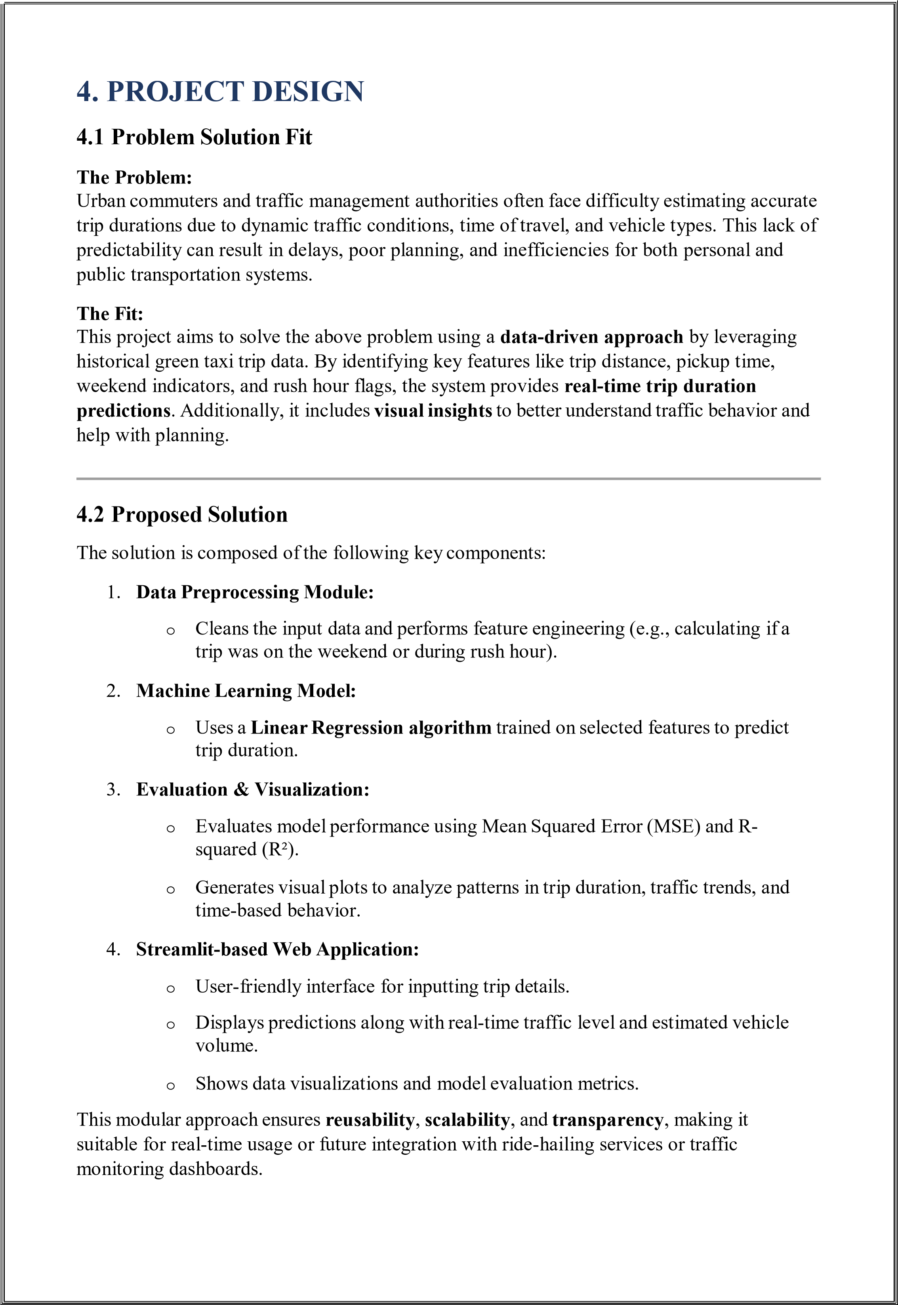

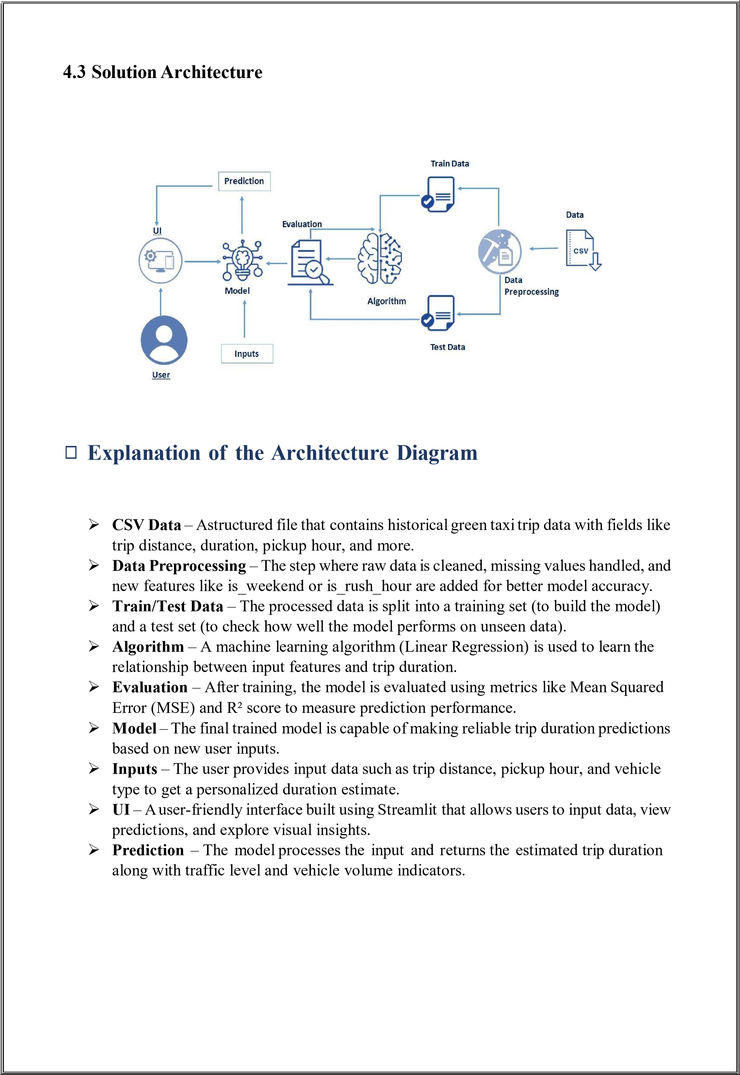

# 5. PROJECT PLANNING & SCHEDULING

## 5.1 Phases and Timeline (24 Days)

The project planning and scheduling for *TrafficTelligence* is structured over a 24-days timeline, divided into seven well-defined phases to ensure smooth execution and timely delivery. It begins with **requirements gathering** and stakeholder analysis, followed by **model design**, **system architecture setup**, and **UI development**, with overlaps to maximize productivity. The **integration and testing** phase ensures seamless coordination between modules, while **evaluation and tuning** optimize performance based on real-world scenarios. The final **documentation and handoff** phase consolidates deliverables and prepares the system for deployment. The schedule is designed for parallel workflows, promoting agility and effective resource utilization throughout the lifecycle.

|  |  |  |
| --- | --- | --- |
| **Phase** | **Days** | **Key Deliverables** |
| Requirements Gathering | Day 1–3 | Define use cases, data sources, stakeholder interviews |
| Model Design & Development | Day 4–9 | Select ML algorithm, feature engineering, training |
| System Architecture Setup | Day 6–10 | Backend setup, APIs design |
| Integration & Testing | Day 11–15 | Real-time data pipeline, model API integration |
| UI Development | Day 13–17 | Interactive dashboard, user input integration |
| Evaluation & Tuning | Day 18–21 | Metrics evaluation, model tuning |
| Documentation & Handoff | Day 22–24 | User guide, architecture documentation, final review |



# 7. RESULTS

## 7.1 Output Screenshots

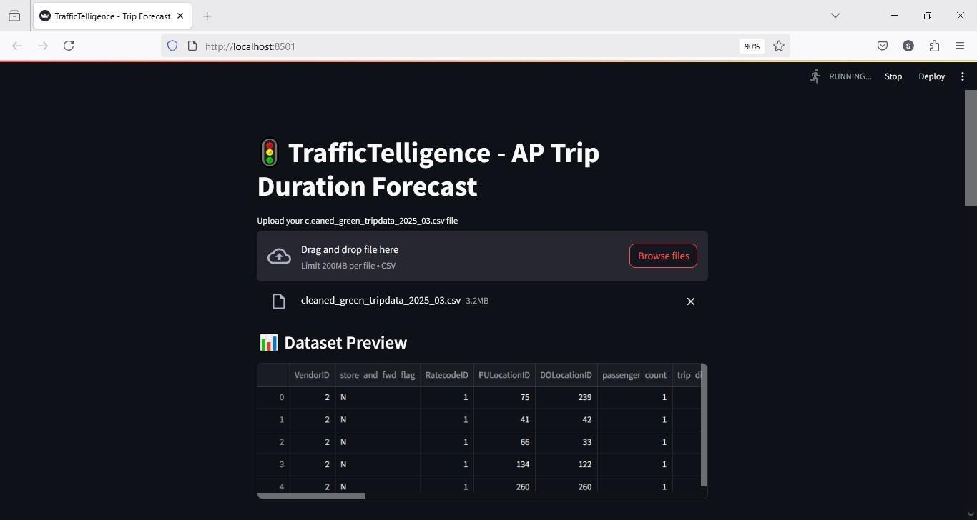

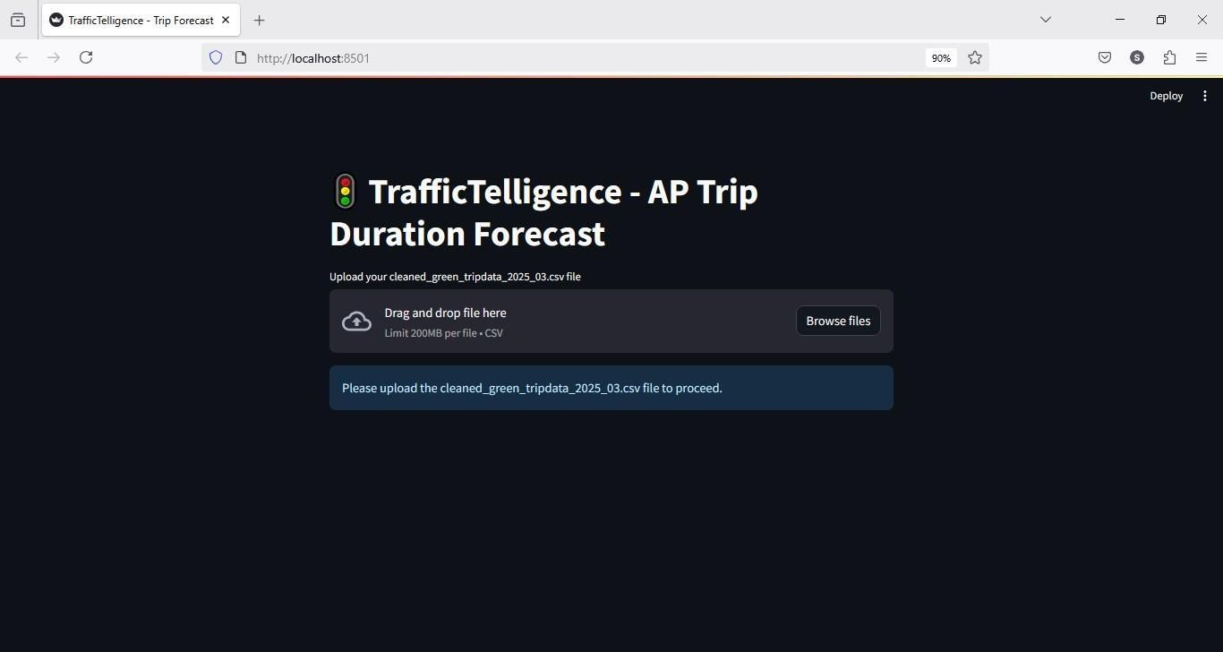

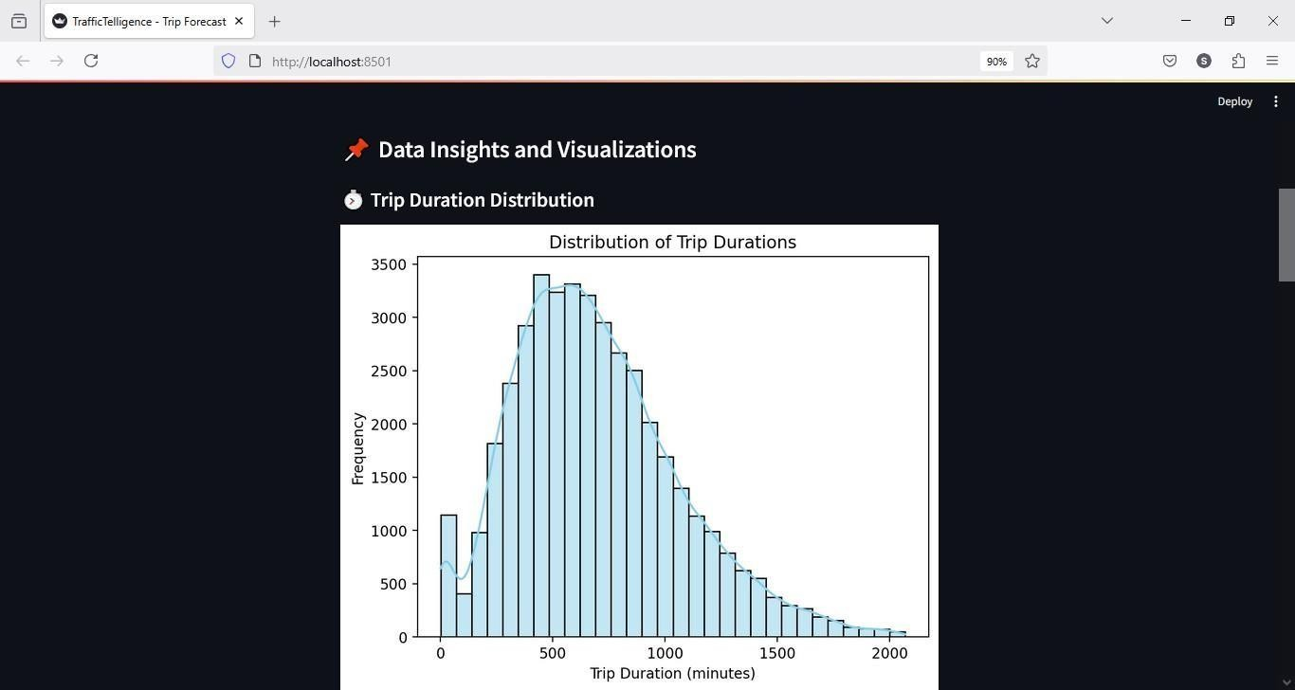

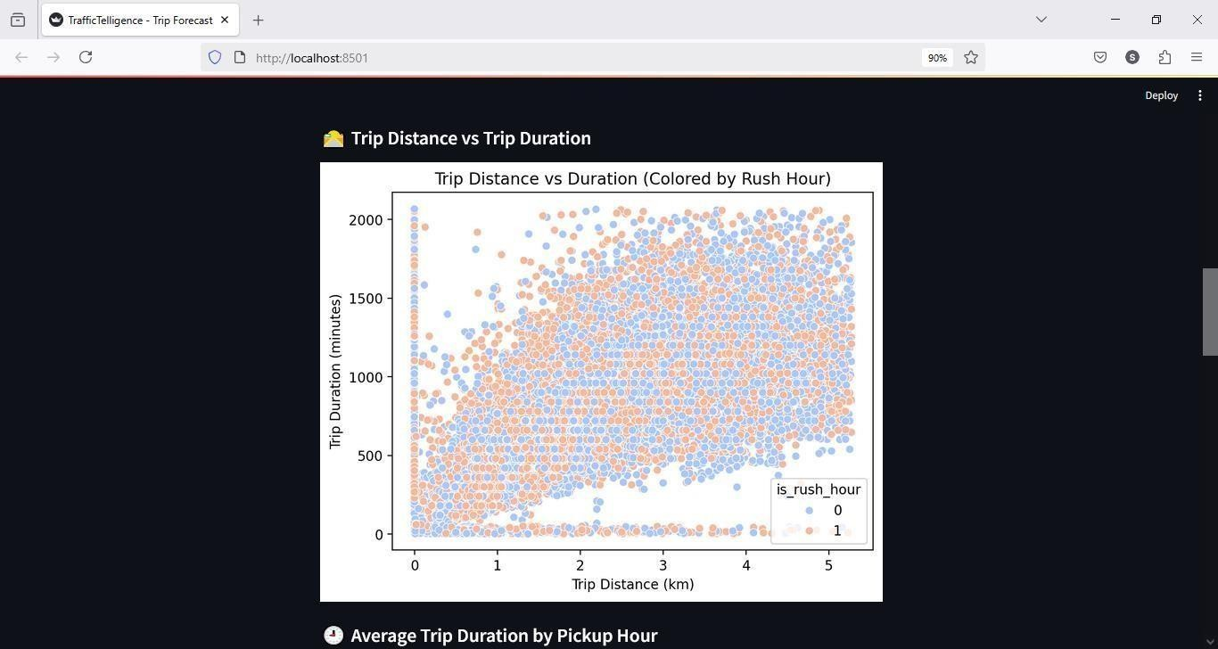

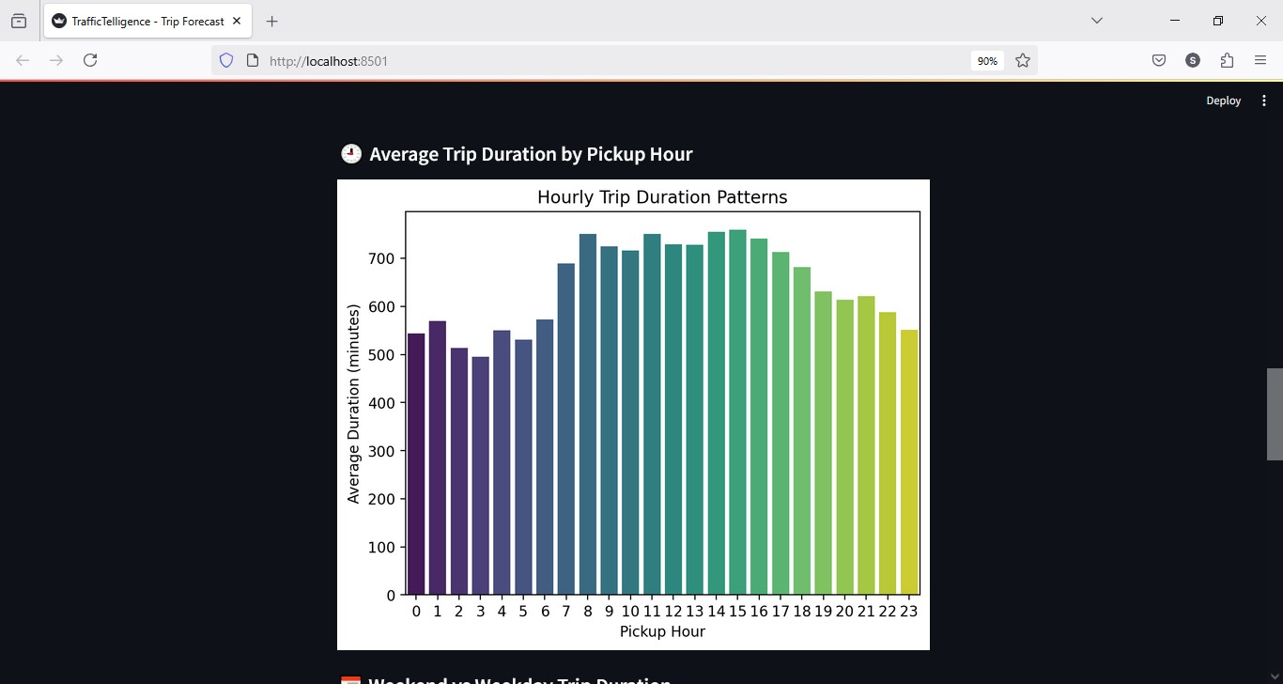

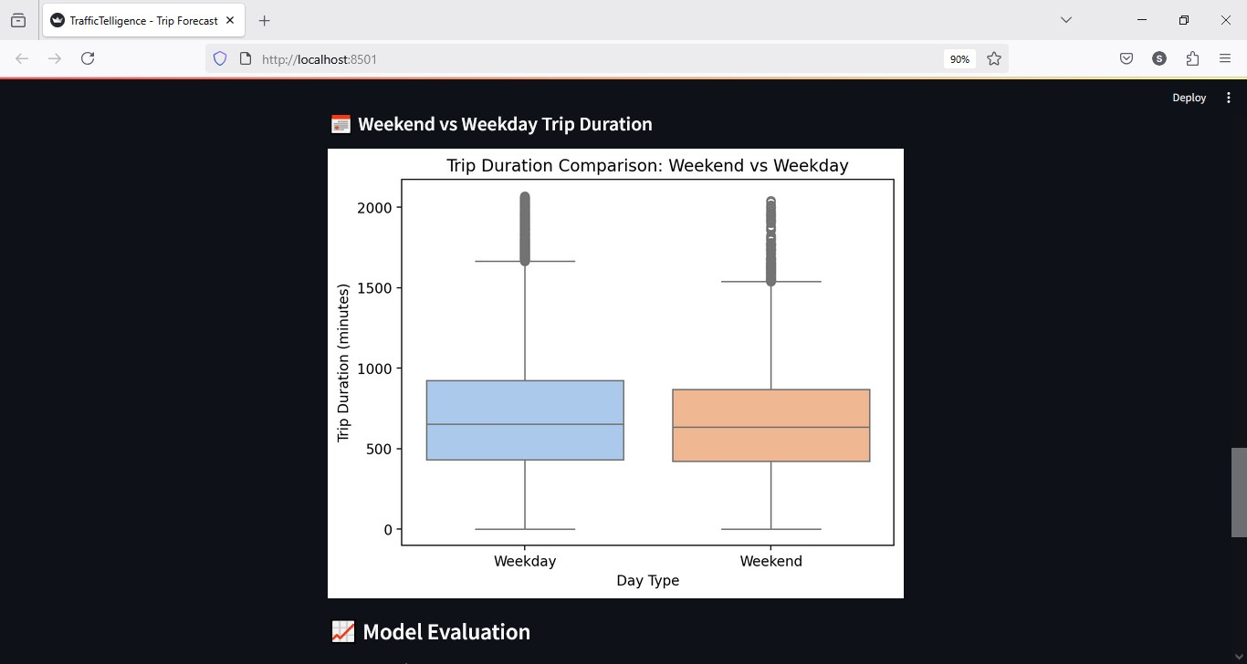

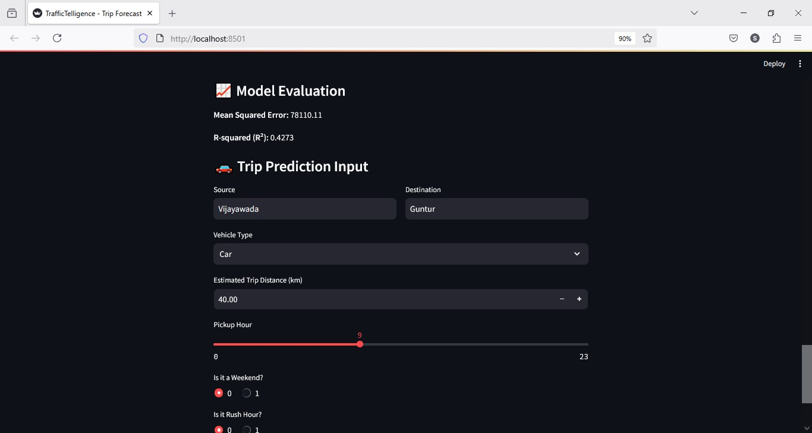

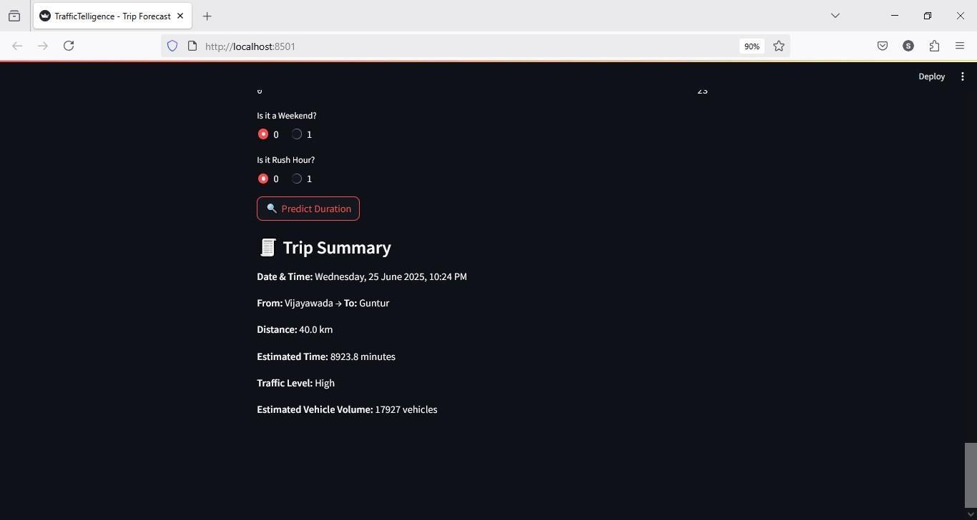

## 8. ADVANTAGES & DISADVANTAGES

### 8.1 Advantages

* **Real-Time Prediction**: The ML-powered system delivers near-instantaneous traffic volume predictions, aiding commuters and authorities in proactive decision-making. 
* **High Accuracy with Historical Data**: By leveraging extensive historical datasets and models like Random Forest and XGBoost, the system ensures high precision in traffic volume estimation. 
* **Cost Efficiency**: Reduces the need for expensive infrastructure like traffic sensors or human-operated traffic studies. 
* **Scalability**: The system is easily scalable to multiple geographies with retraining on localized datasets. 
* **User-Centric Interface**: Streamlit-based GUI ensures accessibility for both technical and non-technical users, improving usability. 
* **Improved Urban Planning**: Authorities can use traffic insights for long-term infrastructure planning and traffic flow optimization. 

### 8.2 Disadvantages

* **Data Quality Sensitivity**: Inaccuracies in historical data, missing values, or outdated datasets can significantly affect prediction reliability. 
* **Model Generalization Limitation**: The ML model may not generalize well to areas with drastically different traffic behaviors or underrepresented events (e.g., festivals, accidents). 
* **No Real-Time Adaptation**: Without live data feeds, the system cannot adjust predictions based on current conditions (e.g., construction or weather). 
* **Maintenance Overhead**: Requires periodic updates, retraining, and system monitoring  to maintain prediction accuracy over time.
* **Dependence on Internet Access**: For cloud-based deployment, users must have a stable internet connection to interact with the system. 

## 9. CONCLUSION

The "Traffic Telligence" project validates the ability of machine learning in addressing real- world challenges like traffic congestion. With the help of structured data pipelines, robust ML models, and a clean UI, the project achieves its core goal—accurate prediction of traffic volume using historical datasets.

The system proves particularly useful in cities struggling with high traffic density, where predictive tools can help manage peak loads, reduce travel time, and enhance commuter experience. Model evaluation using MSE and R² reveals strong predictive power and reliability.

This project not only demonstrates technical competence in machine learning and web deployment but also reflects its potential societal impact. It bridges the gap between advanced analytics and public utility by offering a practical, low-cost solution for traffic forecasting.

Future iterations can enhance this foundation by integrating real-time capabilities and expanding predictive features, showing promise for large-scale adoption in smart city ecosystems.

## 10. FUTURE SCOPE

* **Integration with Real-Time APIs**: Incorporating live feeds from traffic APIs (e.g., Google Maps Traffic, Waze) can significantly improve prediction accuracy and adaptability.
* **Weather & Event-Based Prediction**: Enhancing the model to consider external factors such as weather conditions, road closures, and public events for better context-aware forecasts.
* **Cross-Platform Compatibility**: Developing dedicated Android/iOS applications to make the tool more accessible to daily commuters and on-field personnel.
* **Machine Learning Model Expansion**: Exploring deep learning techniques (LSTMs, CNNs for spatiotemporal analysis) could further improve the accuracy of time-series traffic data prediction.
* **AI-Powered Decision Support System**: Creating an analytics dashboard for government bodies to simulate traffic scenarios and receive AI-suggested interventions.
* **Community Feedback Loop**: Allowing user-submitted traffic updates could create a hybrid system that combines AI predictions with real-world insights.

|  |
| --- |
| **11. APPENDIX**  **Source Code**  The complete source code for the traffic volume estimation project is available in the GitHub repository linked below. It includes data preprocessing scripts, model training code, prediction modules, and the Streamlit UI components.   * **Uploaded in GitHub repo:**    [**https://github.com/shalom-m-vishal/traffic-prediction-project.git**](https://github.com/shalom-m-vishal/traffic-prediction-project.git)  **Dataset Link**  We utilized a publicly available dataset containing historical traffic volume, date and time stamps, and corresponding geolocations. This dataset was preprocessed to extract time- based features and fed into the ML model to improve prediction accuracy.   * **Used traffic volume dataset from:**  [**https://github.com/shalom-m-vishal/traffic-prediction-project/blob/main/green-tripdata- 2025-03.csv**](https://github.com/shalom-m-vishal/traffic-prediction-project/blob/main/green-tripdata-2025-03.csv)     **GitHub & Project Demo Link:**   * **GitHub Repository:**    [**https://github.com/shalom-m-vishal/traffic-prediction-project.git**](https://github.com/shalom-m-vishal/traffic-prediction-project.git)   * **Live Demo Link (Streamlit):**    <https://youtu.be/rHV_kBJkIB4> |